Bug List

From github, open bugs

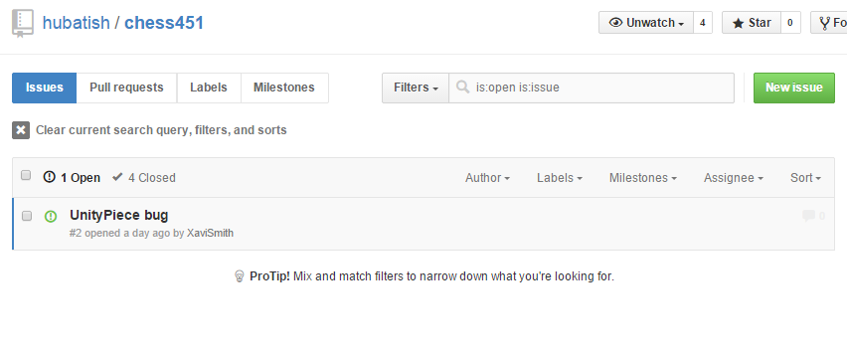

From github, closed bugs

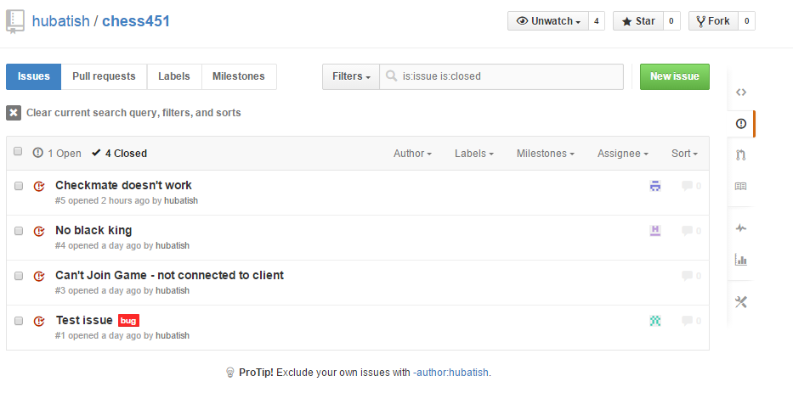

Honestly there are more bugs - many can be seen by which issues fail to pass test cases